Programming Year 10

***Task 2 – Bouncing Ball***

David Charkey

**Contents:**

Page 1 : **Title Page**

Page 2: **Investigation**

Page 3: **Devising**

Page 4: **Evaluation** + **User Instructions** + **Assignment Location**

**Investigating**

**Define the Problem:**

I must create a program in Visual Basic that will ask the user for a height from which a ball will be dropped. The entered height must be less than or equal to ten metres. The program should then calculate the total distance the ball will bounce and how many times the ball will bounce when dropped from the specified height. My program must get the height from the user.

|  |  |  |
| --- | --- | --- |
| **IPO Diagram** | | |
| **Input** | **Process** | **Output** |
| Height Entered | Shows the user a message if the entered height is not less than or equal to ten metres.  Repeat these Instructions until the **Drop Height** is less than 0.01m =  Add 1 to **Total Bounces** every time the instructions are repeated.  Multiply the **Drop Height** by 0.75  Calculates total distance by repeating a calculation.( **Total Distance** + **Drop Height** + (**Drop Height** multiplied by 0.75) | Display Number of Bounces  Display Total Distance Travelled  Reveal Labels |

**Devising**

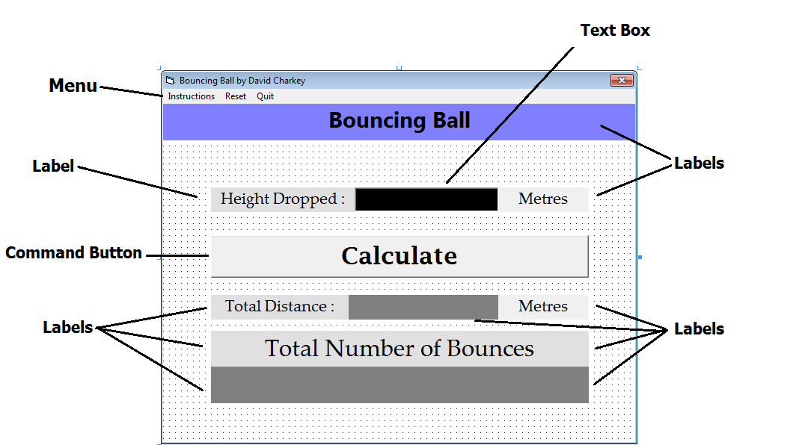

The properties I changed for each object is in a folder called “Other Documents”, it is called **‘Objects’**

For the colours of the form, objects and text, check the above diagram.

The **Pseudocode** for my program is in a folder called “Other Documents”, it is called **‘Pseudocode’**

**Evaluating**

I had some difficulties figuring out which type of loop code to use, but I conducted my own research and discovered which type was suitable.

I had some difficulties formatting the final answer for the total distance. When I entered a value, the program would show all the decimal places for the distance. There were too many digits and the important digits in the tens place were obscured. I then used formatting code to format the final answer to 2 decimal places.

I believe that my program is good because:

* It quickly calculates the wanted information
* It shows units for the values
* It is free of errors and runs smoothly
* It’s user interface is visually appealing
* It is user-friendly (It includes instructions on how to use it)

I believe that my program is bad because:

* It doesn’t have an animation for the ball.
* It is limited to producing results for only a special type of ball.

If I were to produce a second version of my program version I would improve the user interface. I would figure out a way to create an animation for the bouncing ball.

I tested my program for correctness of results by doing my own arithmetic on paper. I also checked my results with other people’s programs.

**User Instructions**

For Internal Documentation, find a folder in the same folder in which this document is located called ‘Other Documents ‘ and inside it you will find a Word document named ‘**Internal Documentation**’

For External Documentation, find a folder in the same folder in which this document is located called ‘Other Documents ‘ and inside it you will find a Word document named ‘**External Documentation’**

If you would like to know how to use the program, check the program’s menu for instructions.

**Assignment Location**

**Location of .exe , .frm. and .vbp =**

Z:\Programming Year 10\Assignments\Task 2 - Bouncing Ball\Project Files

**By David Charkey**